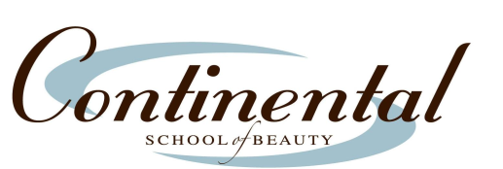

ACCREDITING AGENCY
ANNUAL REPORT STATISTICS
Each year Continental School of Beauty files an annual report with its accrediting agency, The National Accrediting Commission for Career Arts and Sciences (NACCAS). The findings from this report are shared both by individual program and as a cumulative total across all programs.
The following are the results of this report for 2023:

All Schools Total Mattydale Cosmetology Esthetics/Nails Esthetics

Graduation 91% 93% 87% 93% 99%
Placement 70% 70% 76% 72% 62%
Licensure 97% 94% 94% 97% 93%

